Task 3

Class Diagram

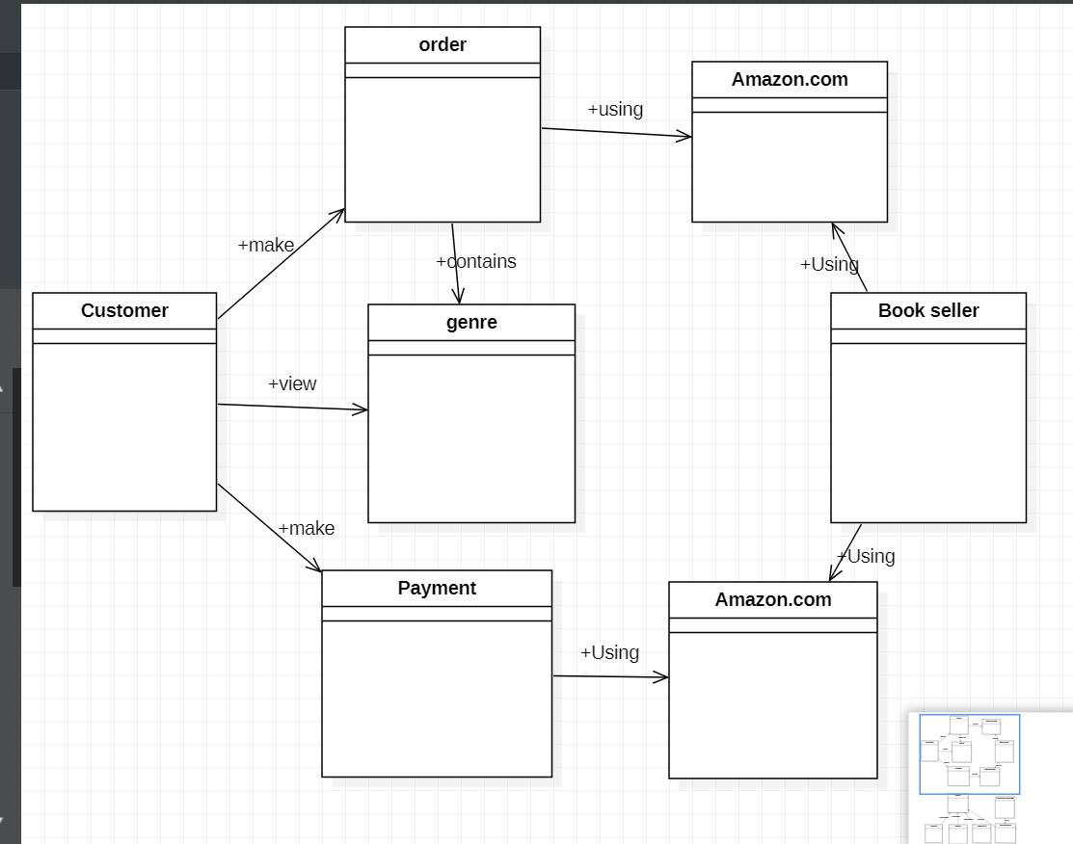

1. Customer make order by using Amazon.com
2. Customer view genre
3. Customer make Payment using Amazon.com
4. Order contains genre
5. Book seller using Amazon.com for receiving Payment
6. Book seller using Amazon.com for receiving order

Factory Design Pattern

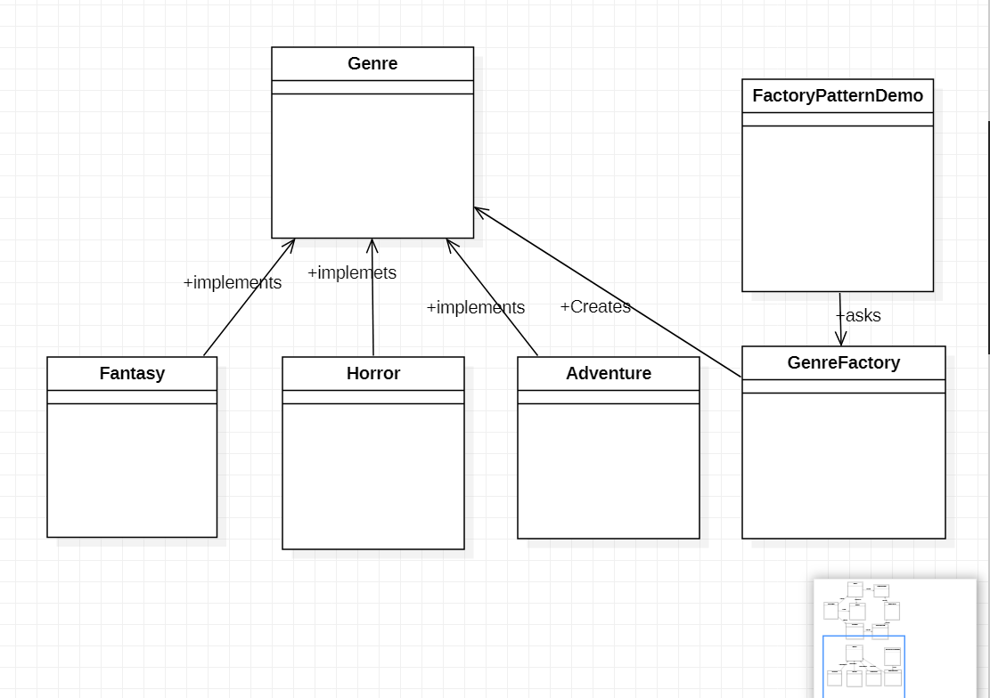

Factory pattern is one of the most used design patterns in Java. This type of design pattern comes under creational pattern as this pattern provides one of the best ways to create an object.

In Factory pattern, we create object without exposing the creation logic to the client and refer to newly created object using a common interface.

It’s very easy to manage. While adding a new storage class, just put that class in the particular package where other similar classes are, register itself in the static block & you are done.

Another advantage of factory pattern is less code changes & no more if else in the factory classes, in fact you don’t need to make any change in the factory class when you add a new storage implementation.

It also follows all solid principle of programming.